**Ideation Phase**

**Revolutionizing Liver Care & Idea Prioritization Template**

|  |  |
| --- | --- |
| **Date** | 16th june, 2025 |
| **Team ID** | LTVIP2025 TMID35397 |
| **Project Name** | Revolutionizing Liver Care : Predicting Liver Cirrhosis Using Advanced Machine Learning Techniques |
| **Maximum Marks** | 4 Marks |

**Problem Statement Definition :**

The project is focused on creating an advanced machine learning-based predictive model to identify the onset or progression of liver cirrhosis in patients. Liver cirrhosis, a severe condition marked by liver tissue scarring due to prolonged damage, requires early detection and intervention to improve patient outcomes and avoid complications. By examining diverse patient data, including medical history, lab results, imaging scans, and lifestyle factors, the model aims to predict the likelihood of liver cirrhosis. This will assist healthcare professionals in making well-informed decisions regarding patient care.

**Step-1 : Team Gathering, Collaboration and Select the Problem Statement**

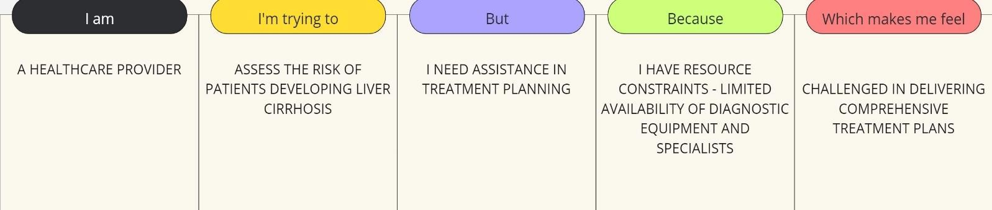

**Step-2: Idea Prioritization**

Idea prioritization is the process of ranking or assessing ideas based on specific criteria such as feasibility, impact, cost, or strategic importance to determine which ideas should be implemented or pursued first.

**Revolutionizing Liver Care: Predicting Liver Cirrhosis Using Advanced Machine Learning Techniques**

Among all the ideas we considered, the most important to us was **"Using AI/ML to analyze past patient data to accurately predict liver cirrhosis."** We prioritized this because if the predictive model lacks accuracy, the entire system's reliability and clinical usefulness would be compromised. Ensuring that the machine learning model delivers precise and dependable predictions is the foundation of our project.

Our second most important idea is **"Collaboration with healthcare institutions and government health agencies to integrate our solution into existing healthcare infrastructure."** This is vital not only for enhancing the practical impact of our work but also for fulfilling our social responsibility. By partnering with hospitals, clinics, and public health bodies, we aim to contribute meaningfully to early diagnosis and prevention—benefiting both healthcare providers and patients.

The third key aspect of our vision involves **"Extending our system to offer advanced features such as treatment recommendation support, patient risk stratification, and public health insights based on liver health data."** Once we achieve our core goal of accurate liver cirrhosis prediction, we plan to expand the system’s functionality. These additional features will significantly increase the overall value and applicability of our project across the healthcare ecosystem.